# Municipal Strategic Planning Scenario

Municipal Strategic Planning Scenario 1

1. Understand the Business Motivation for Change 3

2. Determine the Desired Results 4

3. Capture the Existing Municipal Business Architecture 5

4. Perform Gap Analysis 6

5. Envision the New Municipal Business Architecture 8

6. Analyze Required Services 9

7. Trace Programs and Services to the Business Motivation 15

8. Design the Organizational Structure 16

9. Create Roadmap Plans for Closing the Gaps 18

10. Communicate to Stakeholders 20

There may be many different approaches to municipal strategic planning depending on the business influencers, change drivers, community needs, regulations and political pressures that are motivating change. Municipalities may use assessments of performance indicators to identify key areas for improvement, addressing performance gaps in high-value programs and services. Alternatively, municipalities might analyze community needs in order to assess the gap between existing service outcomes and those required to address the needs. Another approach might involve analyzing the existing municipal business architecture against municipal goals and strategies to determine how to evolve to meet business imperatives. Municipalities may use all of these approaches depending on the influencers and time horizon.

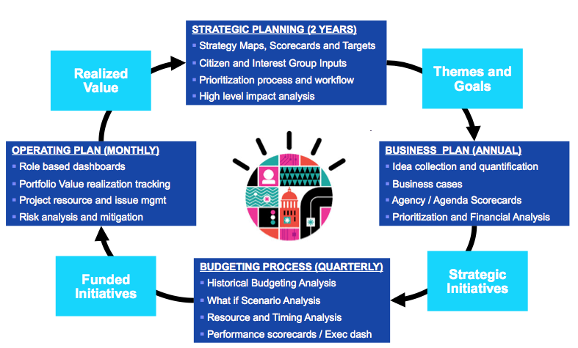

This section describes how to perform activities that municipalities may typically do when analyzing their programs and services in order to close the gap between what they have and what their target groups need. These sections show the general capabilities described above in a specific scenario where they facility capturing, validating, communicating, reasoning about, and acting on municipal models that leverage the MRM.

Using the MRM provides an excellent starting point for municipalities, not only capturing many of the programs and services they already have in a reusable model, but also providing candidate new programs and services that have been proven in practice to effectively meet particular target group needs. The general flow of the activities follows typical architecture development methods (e.g., TOGAF for example).

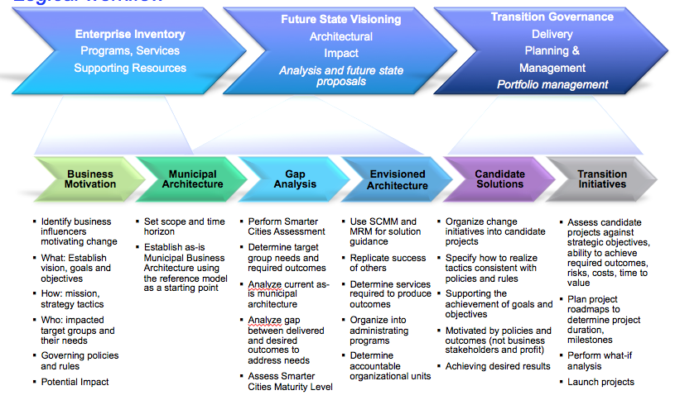

The following subsections expand on these steps, showing how they can be performed using the SDW.

## Understand the Business Motivation for Change

The business motivation captures the influencers that are motivating the municipality to change. Any change costs money and can have unintended consequences. So understanding the influencers provides the context in which goals and strategies can be assessed against potential impact on the municipality. These influencers can include economic challenges, new regulations, environmental disasters, changing social structures, globalization, etc.

* 1. Create the influencers motivating the municipality to change  
     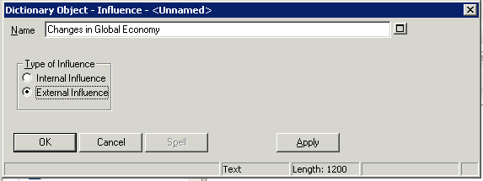
  2. Add the relevant data. Later we will document the objects impacted by these influencers  
     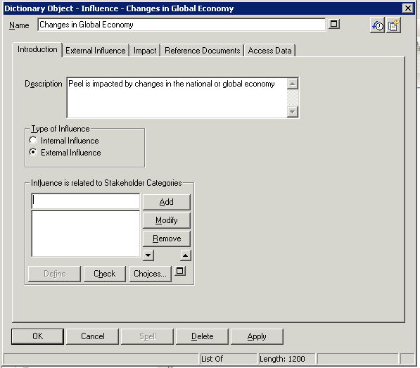

## Determine the Desired Results

Municipalities need to determine how they wish to respond to the influencers motivating them to change, the desired results they wish to achieve as a result of the occurrences of various influencers. These “ends” can be captured in a vision statement for the municipality, which can be amplified by business goals, with the goals quantified by specific, measurable objectives.

1. Create the municipal vision  
   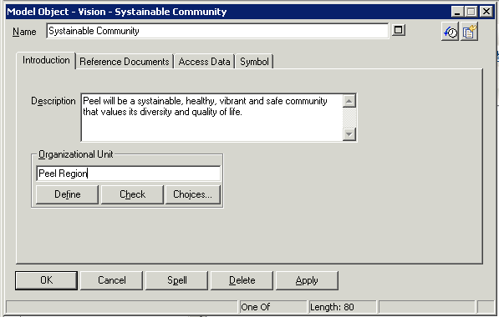
2. Create the mission that channels effort towards the achievement of the vision  
   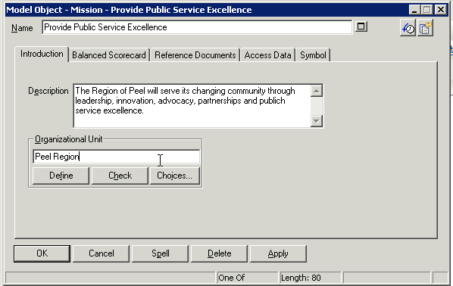
3. Create the goals that amplify the vision and the supporting strategies and tactics  
   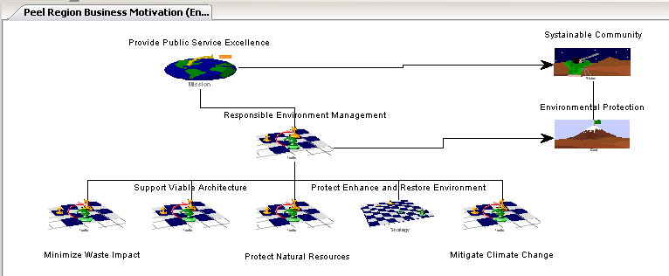

## Capture the Existing Municipal Business Architecture

Managing any kind of change requires a thorough understanding of the current, or as-is situation. Changing something that is complex and poorly understood can often lead to very poor or unexpected outcomes and results. Establishing an as-is municipal architecture would be a huge endeavor in its own right, taking years to complete, and possibly being significantly out of date by the time it is done. Municipalities cannot afford to make costly and time consuming investments in enterprise architecture before they can make decisions about how to address the destruction from the latest tornado or flood.

However, municipalities can easily instantiate the existing Municipal Reference Model, and quickly customize it to reflect their as-is municipal model. The MRM:

* Provides a starting point for developing a municipal model saving potentially years of enterprise architecture development effort
* Contains hundreds of programs and services
* Is based on municipal analysis and best practices over the last 20 years
* Shows municipalities what a good municipal model looks like and provide guiding principles for evolving the model to meet community needs
* Provides a list of candidate programs and services that can be immediately mined to address community needs

A Municipal Model is created by instantiating the reference model. Use the System Architect Encyclopedia Manager to create a municipal model from a backup of the MRMv2 reference model as described above.

## Perform Gap Analysis

Municipalities are accountable to their constituents. These constituents can be organized into Target Groups who are impacted by the occurrence of influencers. Accountability to these target groups depends on a thorough understanding of their needs and the outcomes that address them.

Gaps result from needs unaddressed by any outcomes, or programs, services, processes and/or resources whose assessments against performance indicators to not meet required performance targets.

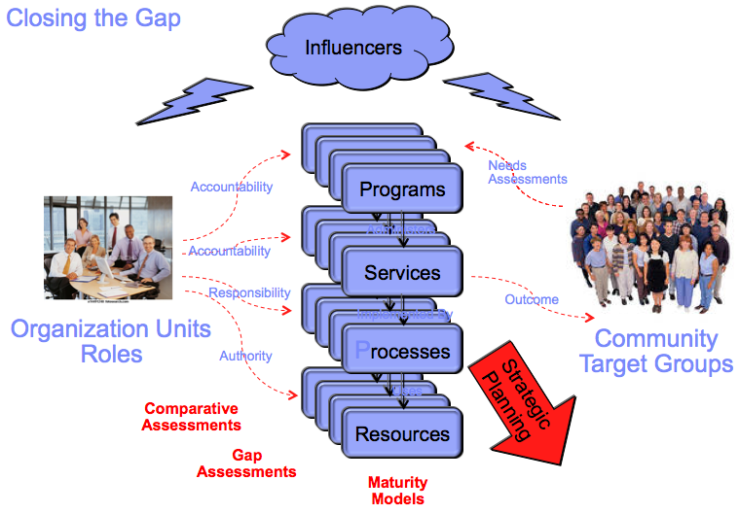

* 1. Create the Public Target Group   
     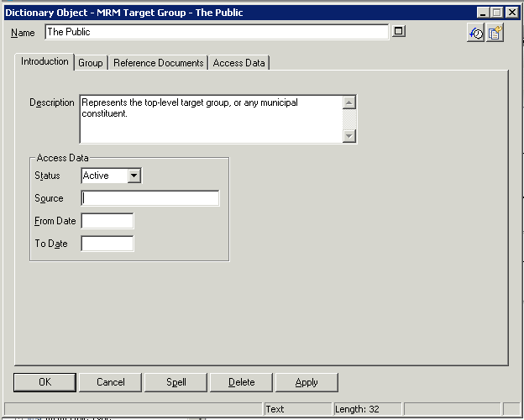
  2. Document a need of the Public for protection from traffic deaths  
     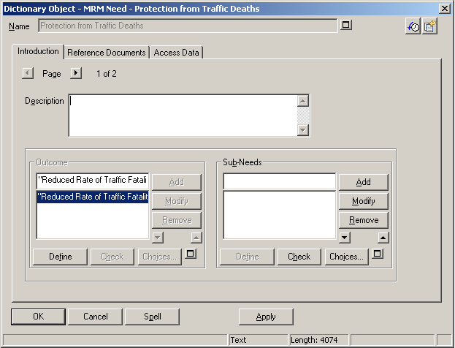
  3. Create the outcome required to address the target group’s need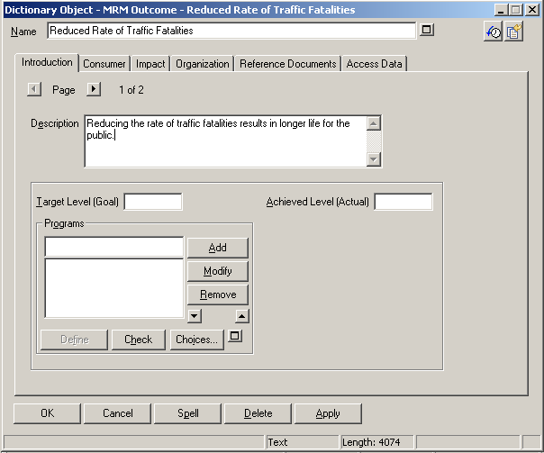
  4. Uses analytics and the Heat Map Manager to assess programs, services, processes and resources against performance indicators  
     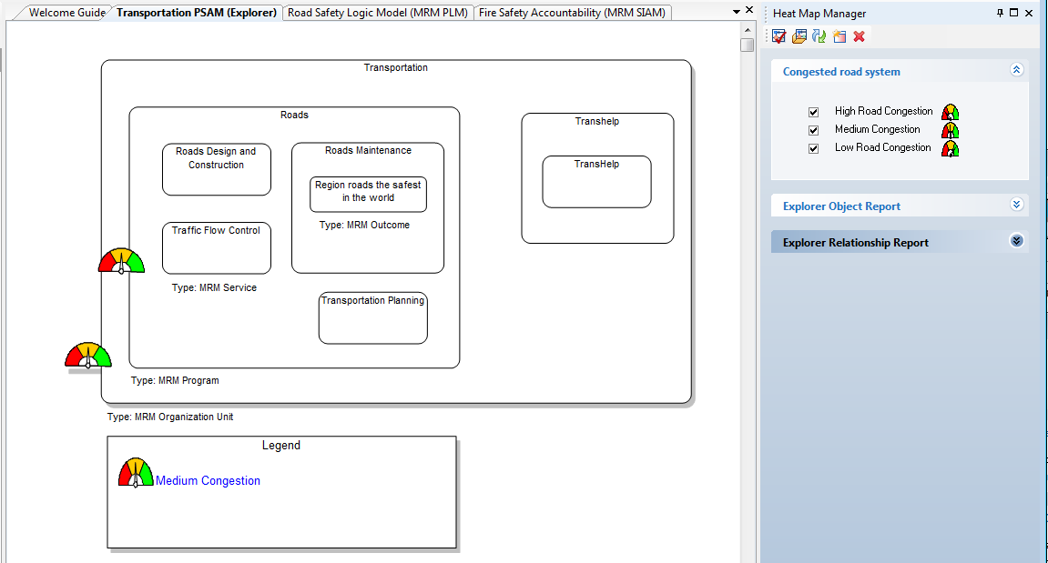

## Envision the New Municipal Business Architecture

Once the business strategy, target groups and their needs are understood, it is possible to envision the programs that are required to deliver outcomes that address those needs.

1. Create a Waste Management Program  
   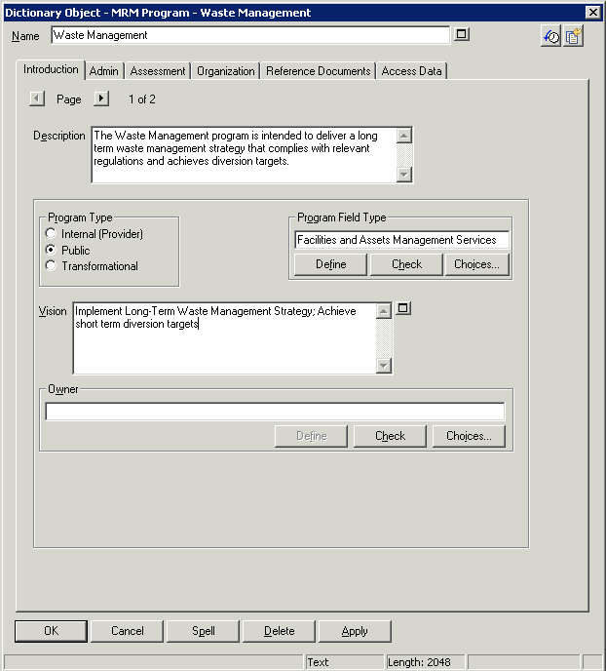

## Analyze Required Services

Determine the services required to produce the output that creates the service value that contributes to the outcomes required to meet target group needs. Services are organized by the programs that administer them in order to provide the desired outcome.

* 1. Create a Driver Licensing Service  
     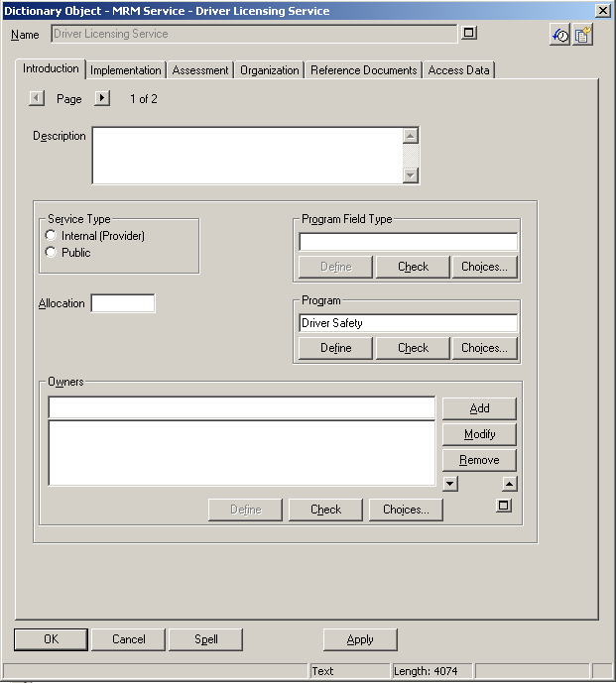
  2. Set the Driver Licensing Service output to “Period of permission to drive motor vehicles on roads”  
     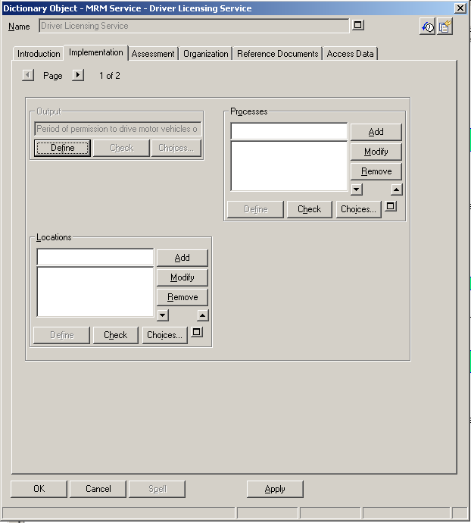  
       
     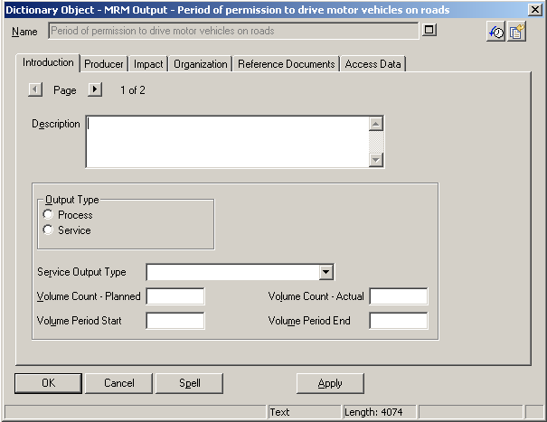
  3. Set the impact of the service output to link to the SV01 Service Value  
     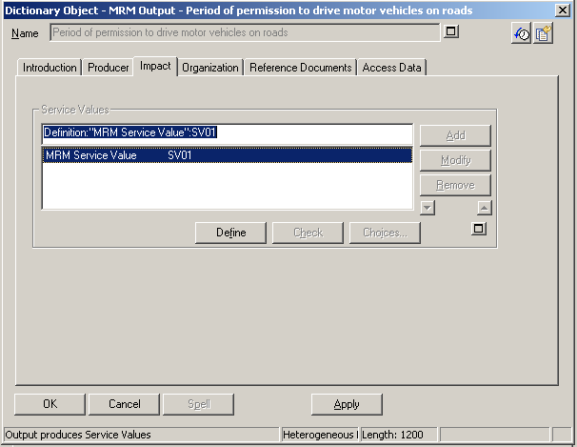  
     which in turn links to the desired outcome:  
     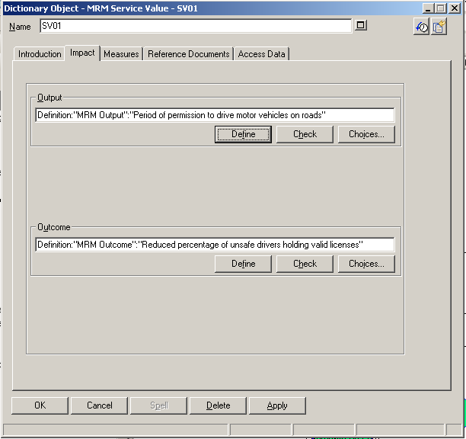
  4. Create a Service Integration and Accountability Model (SIAM) to show the target groups, their needs, the outcomes required to address those needs, and the services that contribute to those outcomes.  
     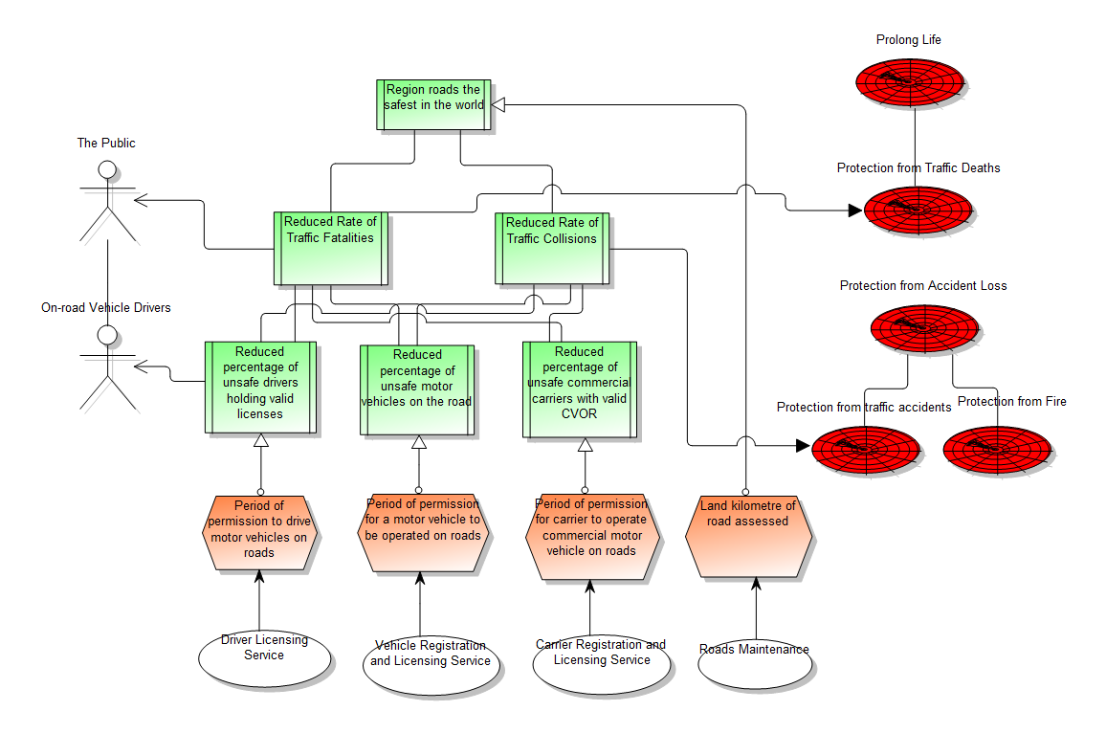
  5. Create a Program Logic Model (PLM) diagram to show the organizations, the programs they are accountable for, the services the programs administer, and the target groups that are impacted by the service output.  
     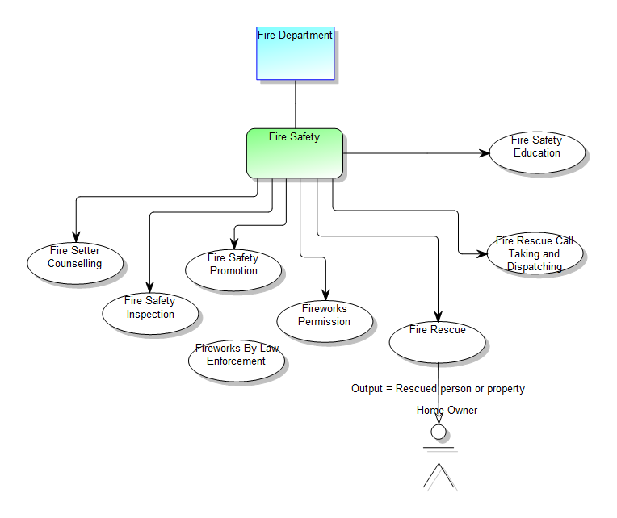
  6. Create a landscape Explorer diagram depicting Program and Service Accountability Model (PSAM) diagram to show an organization unit, the programs it is accountable for, the services those programs administer, and the outcomes the services contribute to:  
     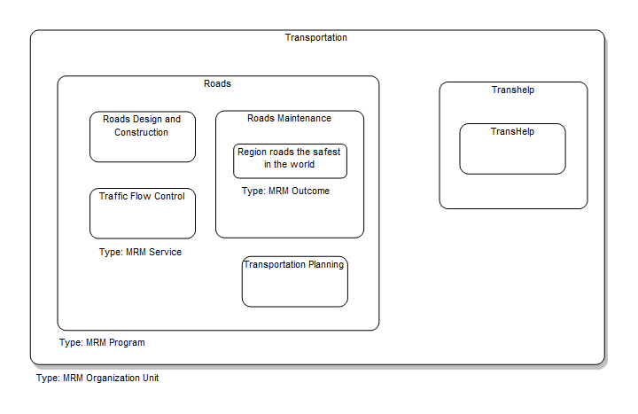
  7. Explorer diagrams can be used to construct views that address specific stakeholder needs. For example, the following figure can be used to explore needs, outcomes and services involved in achieving safe roads. These views can be used to do impact analysis.  
     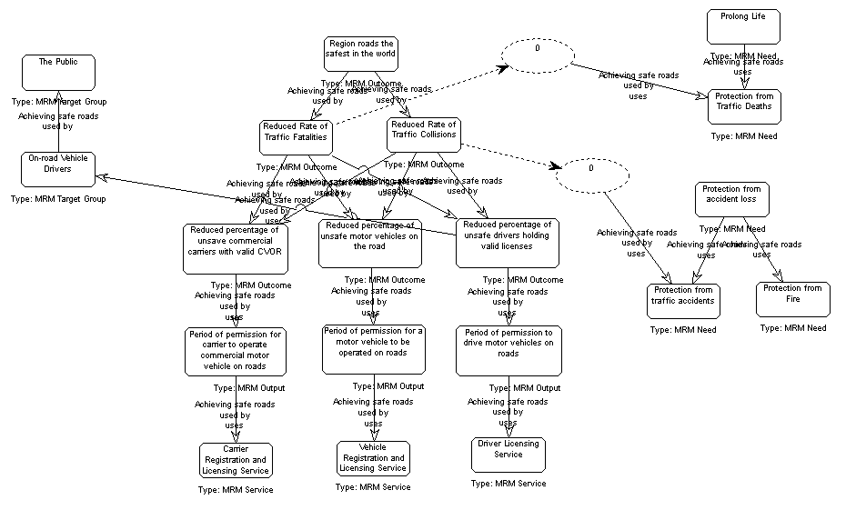

## Trace Programs and Services to the Business Motivation

Limited budgets and other resources constrain the programs and services a municipality can deliver to its constituents. It is therefore important to link the programs and services to the municipal business goals and objectives they address in order to show how those programs and services deliver value consistent with the potential costs.

* 1. Open the Fire Accountabilities SIAM diagram, select the Fire Safety program, right click and select Addresses…  
     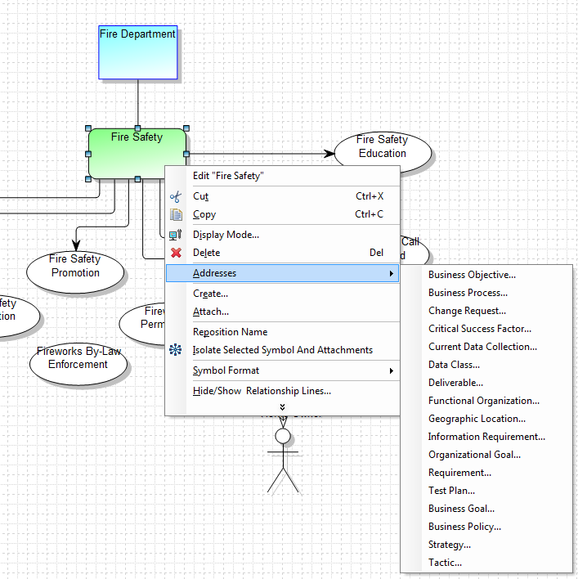
  2. Press the Search button to display the current business objectives or enter a new business objective and press the Lookup button
  3. Select the “Reduce Vehicular Traffic Fatalities by 20%” objective and press the Attach Button. Then press the OK button to indicate the Fire Safety program addresses this objective.  
     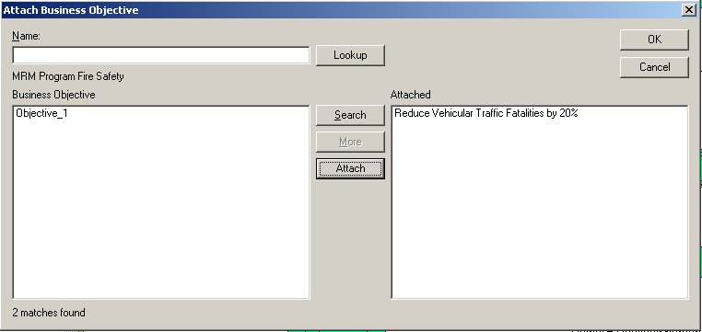

Reports can be created to list what objectives a program addresses.

## Design the Organizational Structure

Organization Units are accountable for programs and services. It is this accountability that helps ensure the value intended from the programs and services is actually achieved.

* 1. View the current Organization Units in the MRM using the Explorer view  
     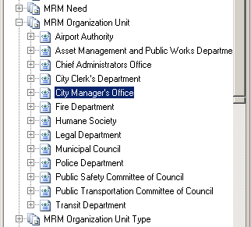
  2. Open the definition for the City Manager’s Office and notice that it is organized as a set of sub-organization units  
     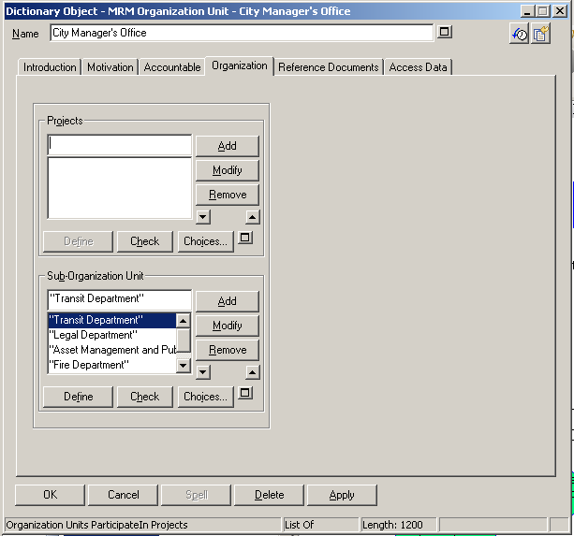
  3. Create an MRM Hierarchy diagram that shows the organization of the City Manager’s Office
     1. Select the Diagrams entry in the Explorer view and invoke New. Then select MRM Hierarchy and press OK to create the diagram. Name the diagram “City Manager’s Office”  
        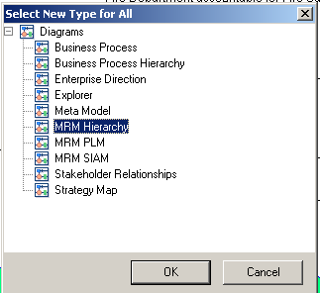
     2. Drag the City Manager’s Office definition in the Explorer view and drop it on the newly created diagram.
     3. Select the City Manager’s Office symbol in the diagram and invoke Tools > Utility Macros > Build Diagram Hierarchy
     4. The organizational structure for the selected organization unit is displayed in the diagram  
        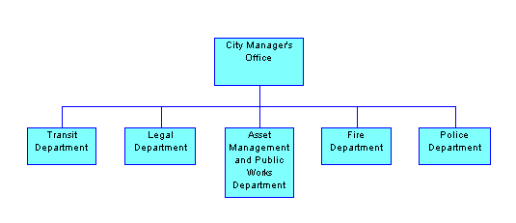

## Create Roadmap Plans for Closing the Gaps

The goal of municipal strategic planning is to determine how to close the gap between what the municipality currently delivers to its constituents, the unaddressed target group needs that arise from changing influencers, and meeting performance objectives. Closing that gap involves action to transition the municipality from where it is to where it needs to be. These transition initiatives can be organized into changes in the municipal business architecture encapsulated in candidate projects. These candidate projects can then be assessed using project portfolio management techniques in order to deliver the most effective proposed changes that support the realization of strategies and tactics and achievement of the municipal goals and objectives.

1. Create a project and set its program, service, process and resource scope, and assign budget estimates  
   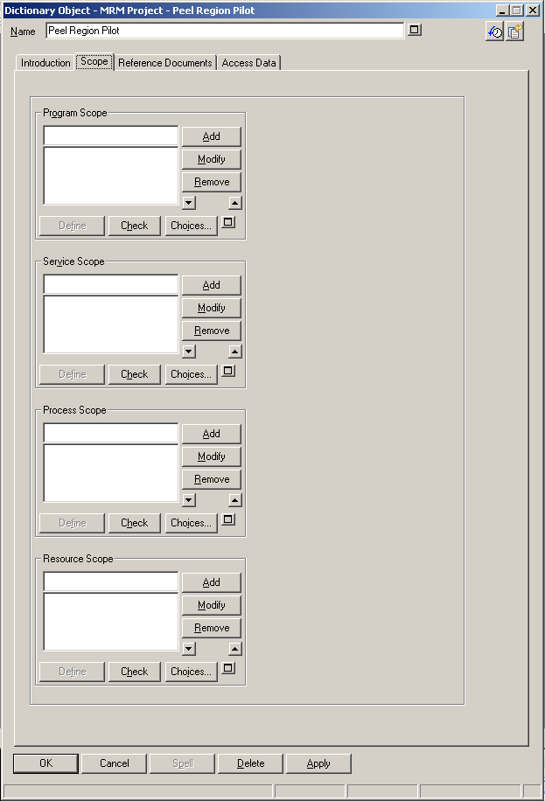
2. This information can now be exported to Focal Point where user can:
   1. Determine project time horizon, major milestones, resource requirements and risks
   2. Assess candidate/pipeline projects against business goals, desired outcomes/outcome value, risks, costs, community preference
   3. Perform what-if analysis to minimize risks and costs while maximizing strategic alignment, citizen value
   4. Manage the lifecycle of projects, including commissioning a project by moving it from a pipeline proposed state to an ongoing, active project.
   5. Track ongoing projects against roadmaps, milestones, budgets, risks, and objectives in order to manage against potentially changing business conditions.

## Communicate to Stakeholders

Determining which candidate projects to take forward requires expression of the goals and supporting strategies to stakeholders who can make decisions. Present the results of the strategic analysis activities to the appropriate stakeholders using various diagrams and reports that effectively communicate how the projects address their needs.

SDW provides a number of ways of producing Web content and publishable documents representing method work products. This section describes how to publish the municipal model to the Web using SA Publisher, and how to create a published work product using Rational Publishing Engine.

1. Publish the municipal model to the Web
   * 1. Start System Architect and open the desired encyclopedia
     2. Invoke Start > All Programs > IBM Rational > IBM Rational Lifecycle Solutions Tools > IBM Rational System Architect > SA Publisher
     3. In the System Architect Publisher dialog, select Existing and select the Municipal Model.xml template  
        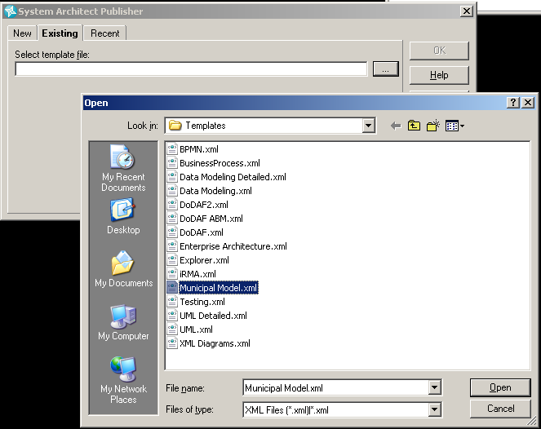
     4. Choose the output folder for the generated website and press Run  
        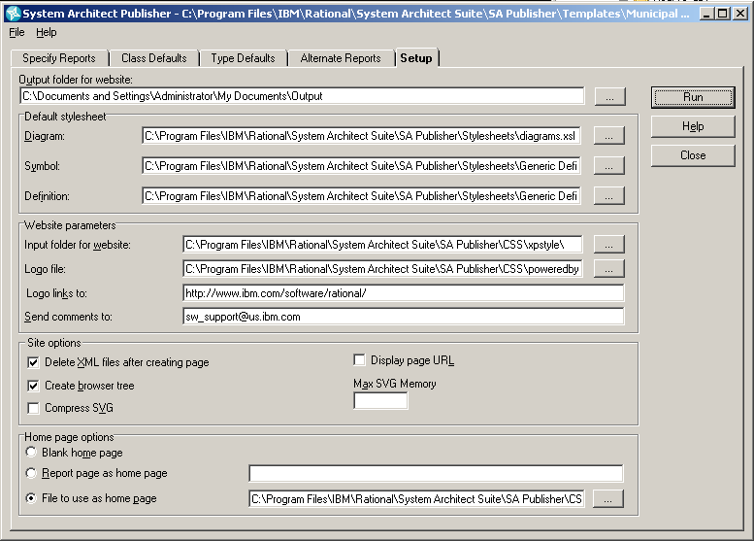
     5. A web browser is automatically opened on the published municipal model
     6. The output folder can be then imported into Quickr
2. Create the Organization Unit Profile work product
3. Make sure the IBM Rational System Architect Rest service is running  
   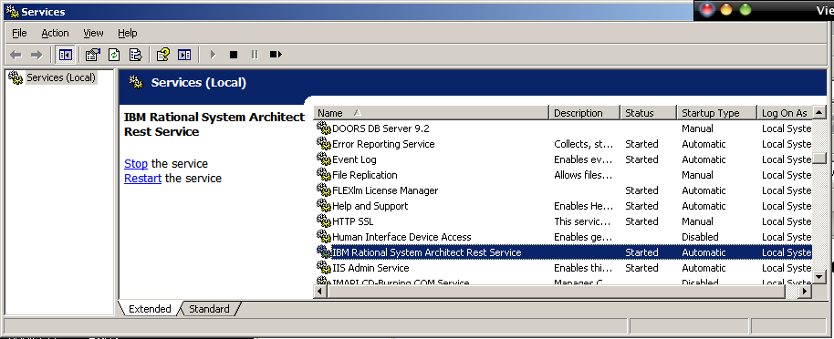
4. Select Start > All Programs > IBM Rational > IBM Rational Publishing Engine Launcher 1.1.1.2
5. Select File > Open Document Specification… and open Organization Unit Profile Report.dsx
6. Under Document Specification, select Output/Target: Word and verify the path and output file name are set as desired  
   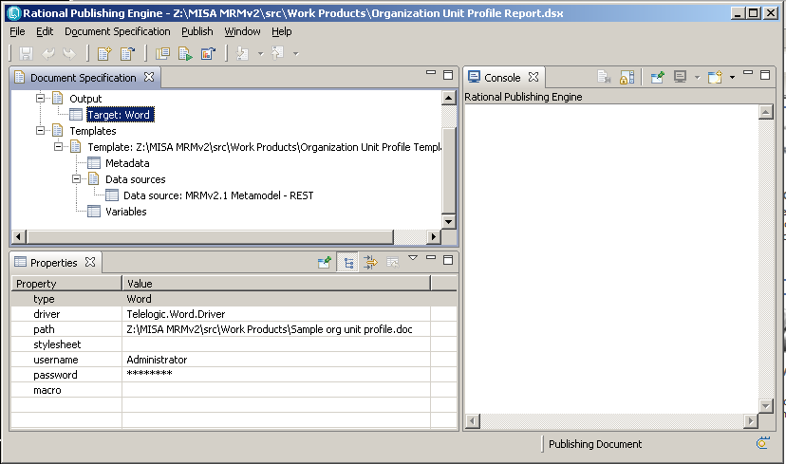
7. Press the Generate Current Document button, or invoke Publish > Generate Document… to select a different document specification to generate
8. The Organization Unit Profile document is generated in the specified output path
9. Open the document with Microsoft Word  
   